**PROJECT TITLE (20pt. bold)**

**REVIEW OF LITERATURE (14pt. bold)**

**Machine Intelligence**

**BACHELOR OF TECHNOLOGY**

**Department of Computer Science & Engineering**

**V Semester Section _ F_ _**

SUBMITTED BY

**Batch No:_ _ _ _**

Student name 1: SRN:

Student name 2: SRN:

Student name 3: SRN:

**PES UNIVERSITY**

**(Established under Karnataka Act No. 16 of 2013)**

**100 Feet Ring Road, BSK III Stage, Bengaluru-560085**

**REVIEW OF LITERATURE**

(Times New Roman, 14, bold, centre alignment)

[1] Fain Yulio Santoso, Hindriyanto Dwi Purnomo, “A Modified Deep Convolutional Network for COVID-19 detection based on chest X-ray images”, *in Dept. of Information Technology, Universitas Kristen Satya Wacana Salatiga, Indonesia.*

< Write about the research work, techniques used, performance parameters, limitations in one paragraph for each paper>

Write for all 9 papers in the same format

Text Style: Time New Roman, Size: 12, Alignment: justified

Abstract:

COVID-19 pandemic caused vast impact worldwide. Many efforts have been made to tackle the pandemic, including in the deep learning community. In this research, a modification of deep neural network based on Xception model is proposed. The model is used for COVID-19

detection based on the chest X-ray images. The proposed model implements two stacks of two dense layers and batch normalization. The layers addition is used to avoid overfitting of the proposed model. The performance of the proposed model is compared to Resnet50, InceptionV3 and Xception. The experiment result shows that the proposed model has better

performance than the other models used in the research. However, its computational time is higher than the other models used in the research.

Research Work:

Many researcher’s have worked and gave their best efforts to fight against Covid-19. The number of people who got affected by Covid-19 were very high which led the researchers to find many ways to tackle this pandemic which also includes the machine learning communities. We can detect Covid-19 with the help of Xray images. Several communities have made many efforts to detect this virus and are still doing. Several strategies have been made and are implemented to detect Covid-19 using Deep Learning Concepts. Various models have been made to detect this virus and have given some exceptional results. Some of the models are ResNet50 [17, 18], Xception and InceptionV3 [19] and Coronet [20]. Rahimzadeh and Attar implement Xception model for Covid19 detection using 15085 images. These models use more number of training images. Yadav et al used InceptionV3 model and used over 30000 training images which achieved an accuracy of 93.77%. On the other hand Makris at el used 336 training images which reduced the accuracy to 54.41%. Therefore this research proposed a modified Xception that work with small number of images training.

Techniques Used:

One aspect of the challenges is the changes of the input distribution to layers in the network when weights are updated. The changes are called internal covariate shift. The proposed model can be explained as follow:

1. The first part of the model uses Xception model except that the layer from the Global Average Pooling to the logistic regression in the exit flow is removed.
2. This part is followed by batch normalization.
3. A dropout layer was added to prevent overfitting.
4. The output of the third batch normalization is the connected to a dense layer before it reaches the output layer.

Performance Parameters:

The dataset used in this research consist of 618 images with 256x256 in size. The data is categorized into normal people, pneumonia and pneumonia caused by COVID-19. The data is categorized into normal people, pneumonia and pneumonia caused by COVID-19. The accuracy of this model in training set is 94.63% and for validation it turned out to have 90.09%.

Limitations:

The processing time for the proposed method is slightly higher that the Xception and significantly higher that the Resnet 50 and InceptionV3.

[2]

Gaurav Labhane, Rutuja Pansare, Anupam Shukla, in *Indian Institute of Information Technology, Pune*

Rutuja Pansare, Saumil Maheshwari, Ritu Tiwari in *ABV-Indian Institute of Information Technology and Management, Gwalior “*Detection of Paediatric Pneumonia from Chest

X-Ray Images using CNN and Transfer Learning*”*

*Abstract:*

Pneumonia is one of the most fatal diseases caused in the lungs. The diagnosis involves a chest x-ray which is interpreted by a radiologist. Human assisted diagnosis has its own limitations like the availability of an expert, cost, etc and hence an automated method for the

detection of pneumonia from x-rays is a necessity. In this research, neural network models were developed to detect pneumonia from the chest x-ray images. Four models namely a basic convolutional neural network (CNN), VGG16, VGG19, InceptionV3 were constructed using CNN and transfer learning methodologies. The models were then trained on a paediatric pneumonia dataset which comprised of 2992 pneumonia and 2972 normal chest X-rays. The results were then tested using 854 pneumonia and 849 normal images, and an accuracy of over 97 percent was obtained from all models.

Research Work:

In February 2018, a group of researchers designed a system based on a deep-learning framework to classify the images for macular degeneration and diabetic retinopathy. It also classified pneumonia and normal chest X-ray images. The model was trained on paediatric chest X-ray images with 5,232 images, out of which 3,883 were pneumonia and 1,349 were normal. Accuracy obtained by them was 92.8% with a93.2% sensitivity and 90.1% specificity. 5856 X-Ray images were divided into two categories namely Pneumonia and Normal as shown in images belonged to the Pneumonia class and 1583 images belonged to the Normal class. Two methods are used to augment the images in the normal class are horizontal flip and zoom, and the number of images in both the classes are made equal.

Techniques Used:

Neural networks are made up of small neurons and each node contains weights that are updated using some techniques called Backpropagation.

Components of a CNN model:

1. Convolution Layer: Basic building block of CNN. They use a filter of fixed size to extract features. The scanning of the image is done by moving the filter as per the strides specified.
2. Batch Normalization: Used to improve the learning rate.
3. Pooling layer: Used to downsample the feature map collected from the convolution layer.
4. Activation: Most commonly used Activation function is RELU. Sigmoid Function is used in the final layer of the two nodes.
5. Dropout: Used to reduce the Overfitting of the model.
6. Dense Layers: Output of convolution layer is flattened and given as input to Dense layers

Performance parameters:

Basic CNN gave 97% accuracy,0.97 recall, 0.97 F1 score and 0.98 Precision. VGG16 gave 98% accuracy, 0.96 recall, 0.98 F1 score and 0.99 Precision. VGG19 gave 97% accuracy,0.95 recall, 0.97 F1 score and 0.99 Precision. InceptionV3 gave 98% accuracy,0.9 recall, 0.97 F1 score and 0.98 Precision.

[3] Usup Bin Keram, Mohd Adib bin Mohd Ramli, Nor Ashikin Mohamad Kamal, Luqmanul Hakim bin Mohd Abas, “Covid-19 Detection from Chest X-Ray Images using Convolutional Neural Network” in Faculty of Computer and Mathematical Sciences University Technology MARA Shah Alam, Selangor

Abstract:

COVID-19 reported cases in Malaysia is increasing every day. The lab facilities for testing COVID-19 have almost reached their capacity. Traditionally, to detect the COVID-19, a swab test is used. This method will take some time and be costly. The swab test kits are very scarce, and the human resources to do this test are limited. Through modern technology, there is a probability of detecting positive COVID-19 using X-ray images with deep learning. In this paper, Convolutional Neural Network (CNN) approach is used to detect Covid-19 through digital X-ray images. The 2D convolution kernel layer consists of three layers. The first layer has a 3 x 3 kernel, the second part has a 5 x 5 kernel, and the third part has a 7 x 7 kernel. Then, the output will be combined into one layer. Afterwards, the concatenated layer continued with another sequential process consisting of two convolution processes, ReLU and max pooling. Next, the model is then flattened, dropout and dense. A total of 2100 positive Covid-19 and negative Covid-19 images from Github and Kaggle databases have been used in this research. Based on the experiment done, the accuracy was almost 96%.

Research Work:

Several studies have used chest X-ray data and deep learning methods to detect Covid-19. They have presented

an investigation on 16 pre-trained CNNs for the classification of COVID-19 using chest CT images. The results reveal that the CNNs performed extremely well on the classification with only six epochs of training. They have compared three multiresolution approaches for chest X-ray image decomposition, namely Wavelet, Shearlet, and Counter let transform. Entropy and energy features were extracted from these three transforms to identify the texture in this image. Next, the results of these three multiresolution methods are compared with fine-tuned ResNet50 pre-trained CNN model. This experiment found that multiresolution approaches produce better results, especially when using the multiresolution Shearlet transform than fine-tuned pre-trained CNN. They have used a combination of deep features from five pre-trained models, namely VGG16, InceptionV3, RestNet50, DenseNet121 and Xception and machine learning classifier, namely Decision Tree, Random Forest, AdaBoost, Bagging and SVM. Of the five pre-trained models, it was found that the combination between Xception and SVM achieved the highest accuracy of 99.33% compared to other models.

Techniques Used:

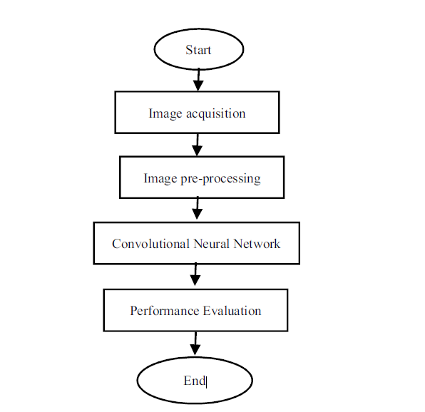

1. Image Acquisition: The sources of the images come from an online database. The total number for positive COVID-19 are 500 images, and the total number for negative COVID-19 is 1600 images.
2. Image Processing: The first step is to convert the image colour by using OpenCV cvtColor function. Even though the image is already in greyscale colour, this function will sharpen the image grey colour more accurately.
3. Convolutional Neural Network: CNN contains several layers of convolution and pooling to generate the result of the assignment.

Performance Parameters:

The precision of the positive Covid-19 class and negative Covid-19 class is 82% and 100%, respectively. The positive Covid-19 class successfully obtained 100%, whereas the negative Covid-19 class obtained 92% sensitivity. For the F-measure, the positive Covid19 class gained 90% and the negative Covid-19 class obtained 96%. Overall, the proposed method managed to obtain 96% for the overall accuracy

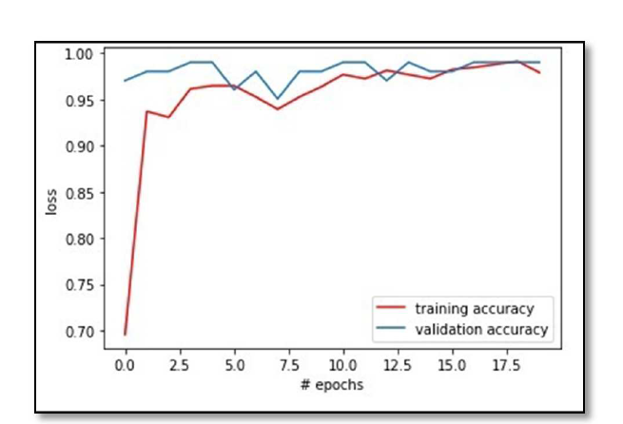.

The loss that the system produce is reduced significantly after the 7.5 epochs. The system learns for the training and testing data quite fast and achieved less loss. This shows the system is reliable in performing the detection.